DOCUMENTATION REPORT

1. System Design

Overview
The system is built using the AdventureWorks2022 database and follows a structured database architecture. It uses stored procedures, triggers, indexing, and transactions to ensure efficiency, integrity, and reliability.

Stored Procedures
- AddNewCustomer:
Inserts customer data into multiple related tables using transactions and error handling.
- UpdateProductPrice:
Updates product prices with validation.
- Deleting/archiving InactiveCustomers
Deleting/Archiving inactive customers based on last purchase
- MonthlySalesReport:
Aggregates sales per month.
- Top10BestSellingProducts:
Returns top-selling products.
- EmployeePerformanceHistory:
Tracks employee order handling.
- Monitoring procedures:
Detect long queries, database size, and index fragmentation.

2. Security Model
The system implements Role-Based Access Control (RBAC).

Roles and Permissions
-SalesRole:
SELECT, INSERT, UPDATE on Sales schema; denied access to HR.
-HRRole:
SELECT, INSERT, UPDATE on HR schema; denied access to Sales.
- DBA_Role:
Full database access.

Users
SalesUser → SalesRole
HRUser → HRRole
DBAUser → DBA_Role

3. Performance Improvements

Before Optimization
Queries were slow due to use of functions like YEAR(OrderDate) .
Example:
WHERE YEAR(OrderDate)=2014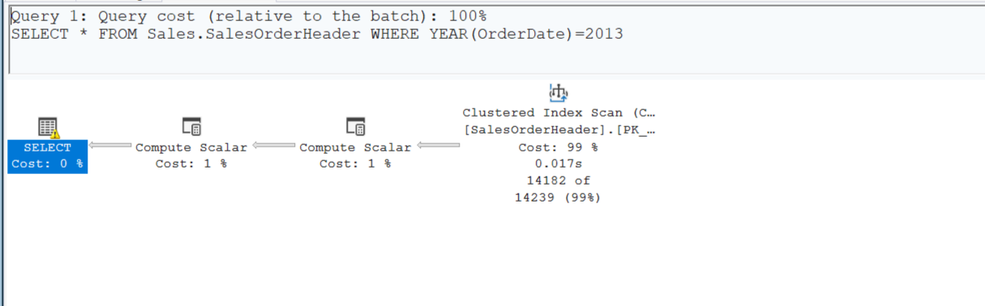

After Optimization
Queries rewritten using date ranges.
Example:
WHERE OrderDate BETWEEN '2014-01-01' AND '2014-12-31'
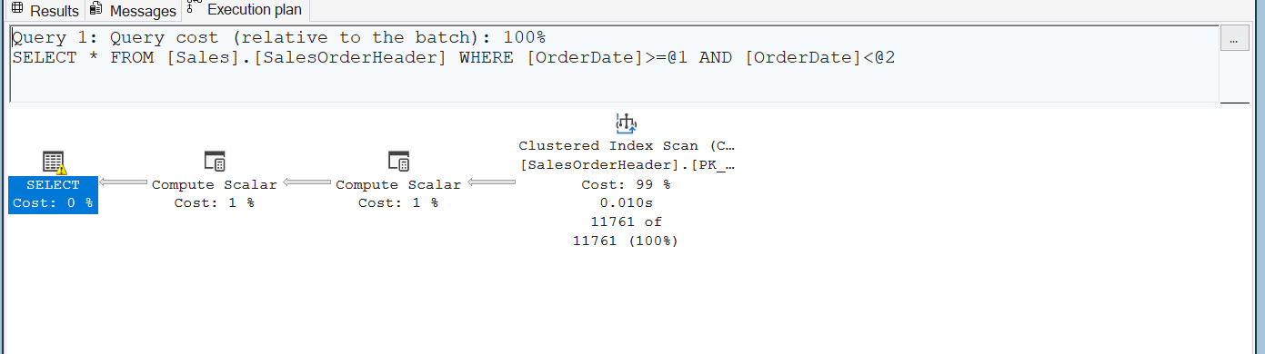

Created Index
CREATE INDEX IN_ORDERQTY
ON Sales.SalesOrderDetail(OrderQty)

Before index:
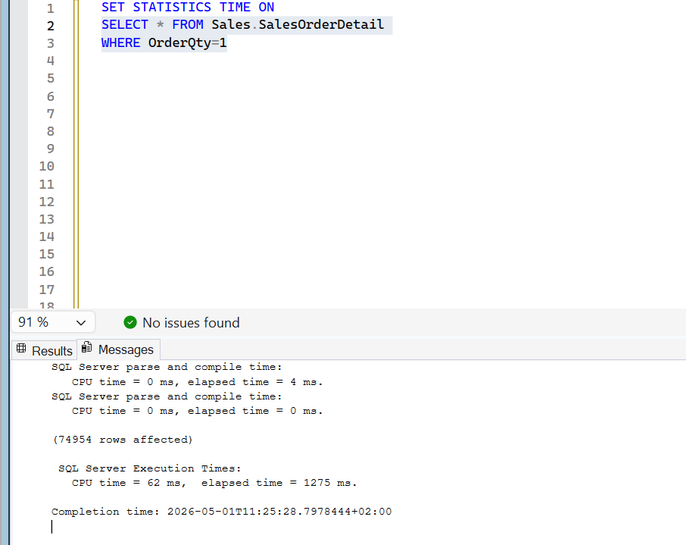

After index:
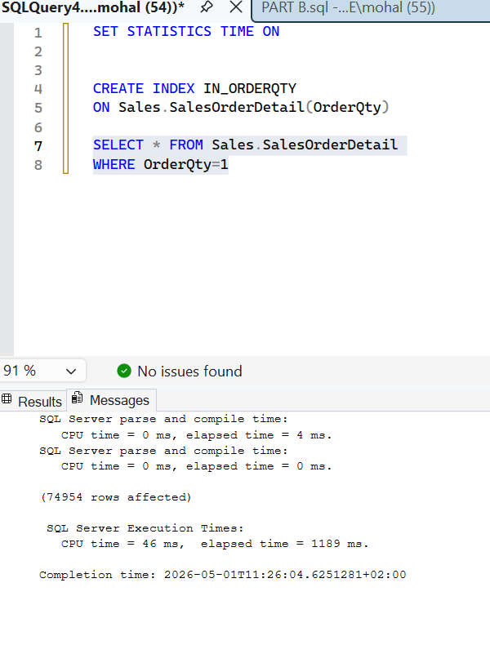

4. Trigger & Alert Design

Audit Table
Stores table name, action type, user, timestamp, and description.

Triggers
Triggers are created on Customer and Product tables for INSERT, UPDATE, DELETE operations.

Logging Process
1. User performs action.
2. Trigger fires automatically.
3. Data is logged into AuditTable with user and timestamp.

Alerts
System logs all activities and can send alerts using Database Mail and SQL Server Agent.

5. Backup Strategy

Backup Types
Full Backup: Weekly
Differential Backup: Daily
Transaction Log Backup: Every 15–30 minutes

Recovery Plan
1. Restore full backup.
2. Restore differential backup.
3. Restore transaction logs for point-in-time recovery.

